Task 1:
Aim: To check whether a given integer number is even or odd and return Algorithm:
- Start
- Read an integer n
- Check if n % 2 == 0
  - If true, return 1 (Even)
  - Else, return 0 (Odd) 4 Print the returned value
5 Stop
Program:
import java.util.;
public class Main
{
static int isEven(int n)
{
if (n % 2 == 0) return 1;
else
return 0;
}
public static void main(String[] args)
{
Scanner sc = new Scanner(System.in); int n = sc.nextInt(); System.out.print(isEven(n));
sc.close();
}
}
Output:

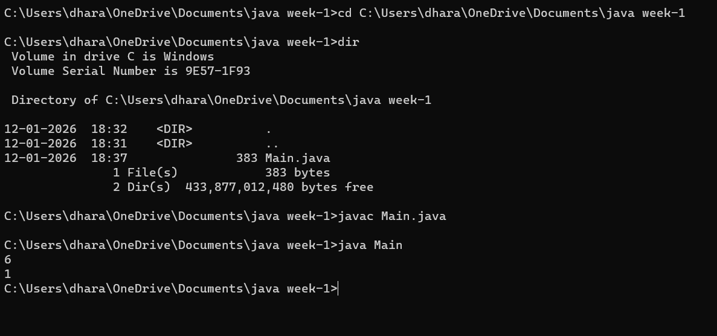

Result: Thus finding the Even or odd is shown sucssesfully

Task2:
Aim: To access and print the element present at a given index in an array.
Algorithm:
- Start
- Read the size of the array n
- Read n elements into the array
- Read the index value index
- Check whether index is valid
  - If index ≥ 0 and index < n, print the element at that index
  - Else, print an error message (invalid index)
- Stop
Program:
import java.util.Scanner;
public class ArrayIndexAccess
{
public static void main(String[] args)
{
Scanner sc = new Scanner(System.in); int[] arr = {10, 20, 30, 40, 50}; System.out.print("Enter index: ");
int index = sc.nextInt();
if (index >= 0 && index < arr.length)
{
System.out.println("Element at index " + index + " is: " + arr[index]);
}
else
{
System.out.println("Invalid index!");
}
sc.close();
}
Output:

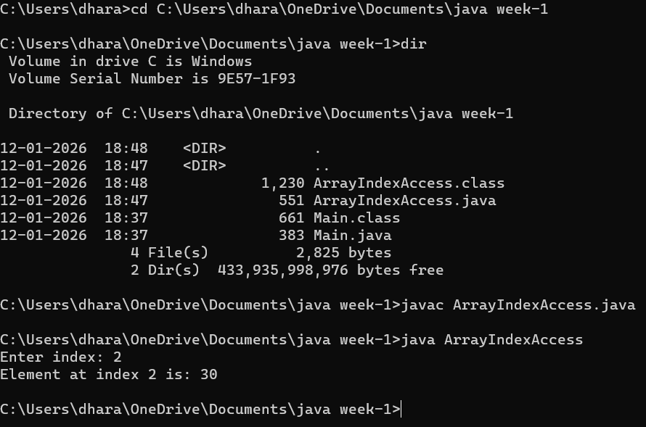

Result: Thus finding the element at index was shown sucessfully

Task3:
Aim: To search for a given element in a sorted array using Binary Search technique.
Algorithm:
- Start
- Read the number of elements n
- Read the n elements of the sorted array
- Read the element to be searched key
- Initialize low = 0 and high = n − 1
- Repeat while low ≤ high
  - Calculate mid = (low + high) / 2
  - If array[mid] == key, print the position and stop
  - If key < array[mid], set high = mid − 1
  - Else, set low = mid + 1
- If the element is not found, print “Element not found”
- Stop
Program:
import java.util.Scanner;
public class BinarySearchExample
{
public static void main(String[] args)
{
Scanner sc = new Scanner(System.in);
int[] arr = {10, 20, 30, 40, 50, 60, 70}; System.out.print("Enter element to search: "); int key = sc.nextInt(); int low = 0;
int high = arr.length - 1; boolean found = false;
while (low <= high)
{
int mid = (low + high) / 2;
if (arr[mid] == key)
{
System.out.println("Element found at index: " + mid); found = true;
break;
}
else if (arr[mid] < key)
{
low = mid + 1;
}
Else
{
high = mid - 1;
}
}
if (!found)
{
System.out.println("Element not found");
}
sc.close();
}
}

Output:

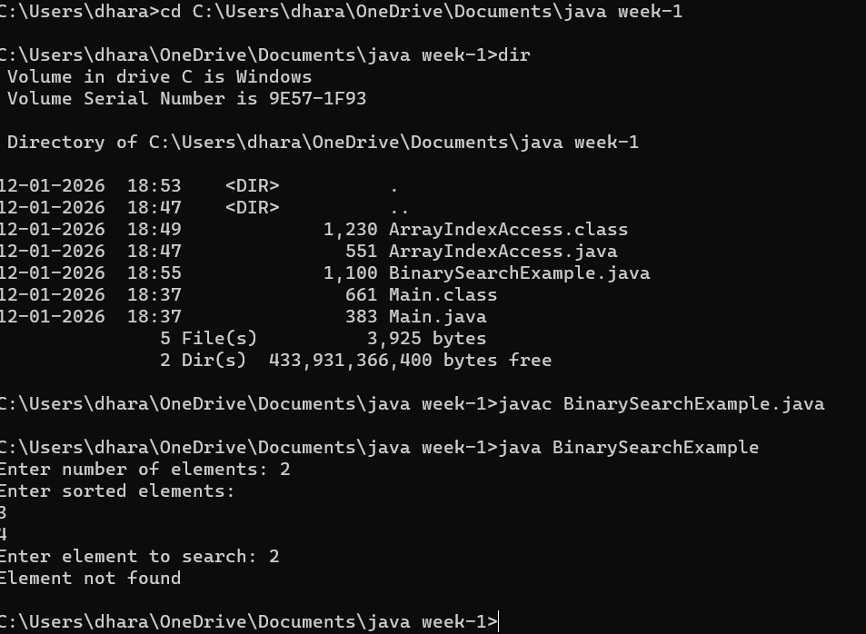

Result: Thus finding the element in sorted array using binary search is shown successfully

Task4:
Aim: To find the maximum element in an array of n integers.
Algorithm:
- Start
- Read the number of elements n
- Read n integers into the array
- Assume the first element of the array as maximum
  - max = array[0]
- Compare max with each remaining element of the array
  - If any element is greater than max, update max
- After completing the loop, max contains the largest element
- Print the value of max
- Stop
Program:
import java.util.Scanner;
public class MaxElementArray
{
public static void main(String[] args)
{
Scanner sc = new Scanner(System.in); System.out.print("Enter number of elements: ");
int n = sc.nextInt(); int[] arr = new int[n];
System.out.println("Enter array elements:");
for (int i = 0; i < n; i++)
{ arr[i] = sc.nextInt();
}
int max = arr[0];
for (int i = 1; i < n; i++) { if (arr[i] > max)
}
Output:

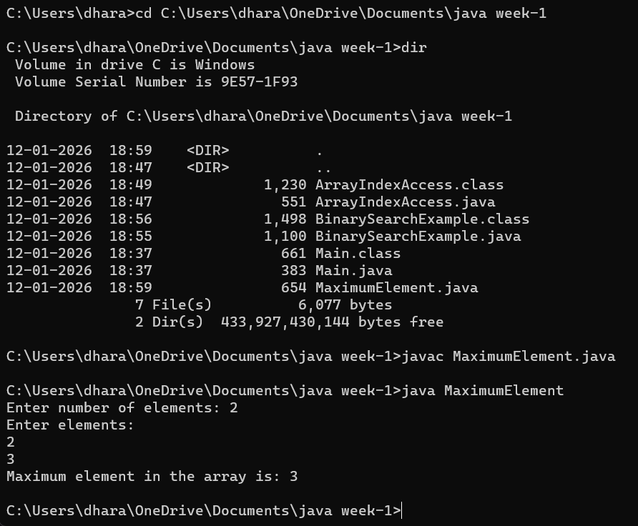

Result:Thus finding the max element was shown successfully

Task5:
Aim: To find the Kth smallest element in a given array of integers.
Algorithm:
- Start
- Read the number of elements n
- Read n integers into the array
- Read the positive integer k
- Sort the array in ascending order
- The element at index k − 1 is the Kth smallest element
- Print the Kth smallest element
- Stop
Program:
import java.util.Arrays;
import java.util.Scanner;
public class KthSmallest
{
public static void main(String[] args)
{
Scanner sc = new Scanner(System.in); System.out.print("Enter number of elements: "); int n = sc.nextInt();
int[] arr = new int[n];
System.out.println("Enter array elements:"); for (int i = 0; i < n; i++)
{
arr[i] = sc.nextInt();
}

System.out.print("Enter K: "); int k = sc.nextInt(); Arrays.sort(arr) if (k > 0 && k <= n)
{
System.out.println("Kth smallest element is: " + arr[k - 1]);
}
else
{
System.out.println("Invalid K value");
}
sc.close();
}
}

Output:

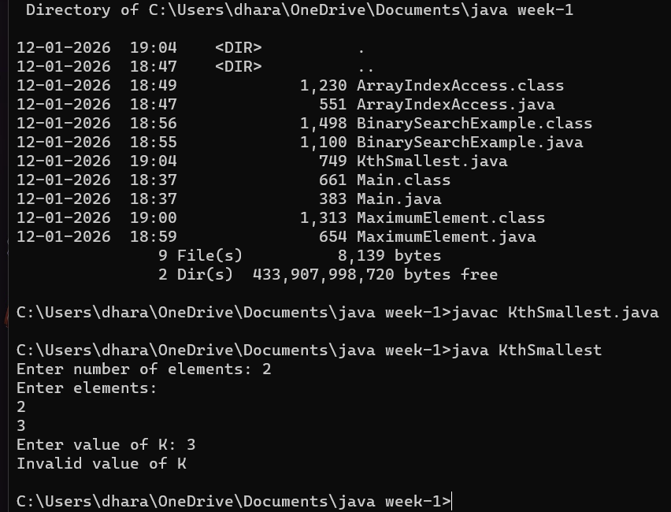

Result: Thus Finding the kth smallest element was shown successfully

Task6:
Aim: To print all possible pairs of elements from an array of size n.
Algorithm:
- Start
- Read the number of elements n
- Read n elements into the array
- Use two nested loops to generate pairs
  - Outer loop from i = 0 to n − 1
  - Inner loop from j = i + 1 to n − 1
- Print the pair (array[i], array[j])
- Repeat until all possible pairs are printed
- Stop
Program:
import java.util.Scanner;
public class PrintAllPairs
{
public static void main(String[] args)
{
Scanner sc = new Scanner(System.in);
System.out.print("Enter number of elements: ");
int n = sc.nextInt(); int[] arr = new int[n];
System.out.println("Enter array elements:"); for (int i = 0; i < n; i++)
{
arr[i] = sc.nextInt(); }
System.out.println("All possible pairs are:");

for (int i = 0; i < n; i++) { for (int j = i + 1; j < n; j++) {
System.out.println("(" + arr[i] + ", " + arr[j] + ")");
}
}
sc.close();
}
}
Output:
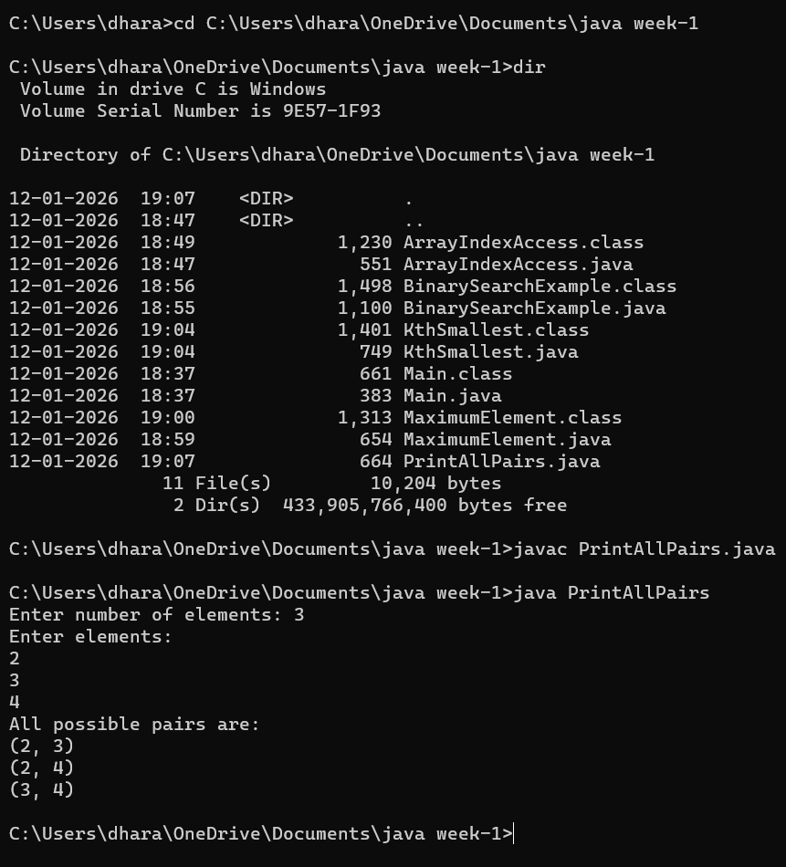

Result:Thus Finding the All pairs of elements was shown Sucessfully

Task7:
Aim: To calculate the sum of even digits or odd digits of a given number based on the user’s choice.
Algorithm:
- Start
- Read an integer input1 and a string input2
- Initialize sum = 0
- Repeat while input1 > 0to
  - Extract the last digit using digit = input1 % 10
  - If input2 is "even" and digit is even, add digit to sum
  - If input2 is "odd" and digit is odd, add digit to sum
  - Remove the last digit using input1 = input1 / 10
- Return sum
- Stop
Program:
class UserMainCode
{
public int evenodddigitSum(int input1, String input2)
{
int sum = 0; while (input1 > 0)
{
int digit = input1 % 10;

if (input2.equalsIgnoreCase("even") && digit % 2 == 0) {
sum += digit;
}
else if (input2.equalsIgnoreCase("odd") && digit % 2 != 0)
{
sum += digit;
}
input1 = input1 / 10;
}
return sum;
}
}
Output:
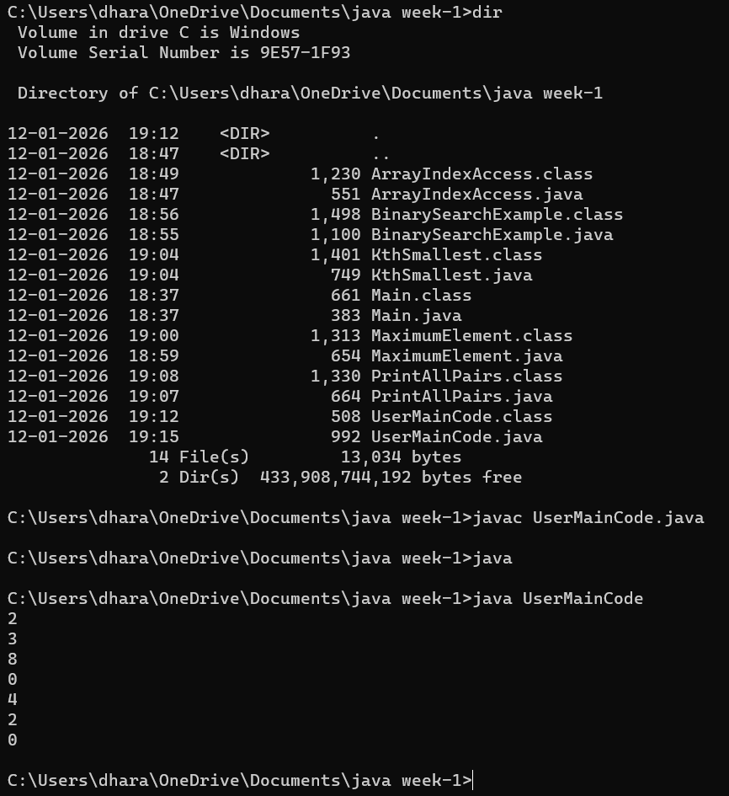

Result:Thus to calculate sum of even digits was shown sucessfully

Task:8
Aim: To find the Nᵗʰ Fibonacci number using an iterative approach.
Algorithm:
- Start
- Read the integer value input1 (position of Fibonacci series)
- If input1 is equal to 1, return 0
- If input1 is equal to 2, return 1
- Initialize two variables:
o a = 0 (first Fibonacci number) o b = 1 (second Fibonacci number)
- Repeat the following steps from i = 3 to input1:
Compute c = a + b
Assign a = b
Assign b = c
- After the loop ends, return the value of b as the Nᵗʰ Fibonacci number
- Stop
Program:
class UserMainCode
{
public int nthFibonacci(int input1)
{
if (input1 == 1) return 0; if (input1 == 2) return 1;

int a = 0, b = 1, c;
for (int i = 3; i <= input1; i++)
{
c = a + b; a = b; b = c;
}
return b;
}
}
Output:
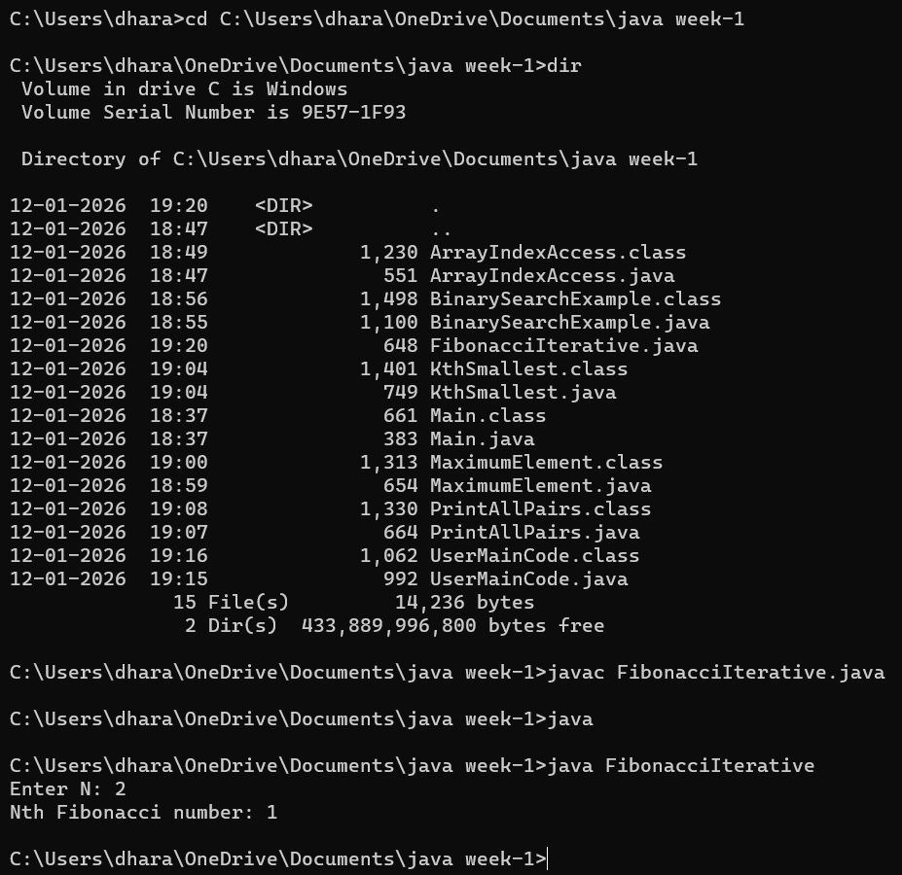

Result:Thus finding the Nth Fibonaci was shown sucessfully

Task9:
AIM: To check whether a given number is a palindrome number and return Algorithm:
- Start
- Read the integer value input1
- Store the value of input1 in a variable original
- Initialize reverse = 0
- Repeat the following steps while input1 > 0:
  - Extract the last digit using digit = input1 % 10
  - Form the reversed number using reverse = reverse * 10 + digit
  - Remove the last digit using input1 = input1 / 10
- Compare original with reverse o If both are equal, return 2 (palindrome) o Otherwise, return 1 (not palindrome)
- Stop Program:
class UserMainCode
{
public int isPalinNum(int input1)
{
int original = input1; int reverse = 0;

while (input1 > 0)
{
int digit = input1 % 10;
reverse = reverse * 10 + digit; input1 = input1 / 10;
}

if (original == reverse) return 2;
else
return 1;
}
}
Output:
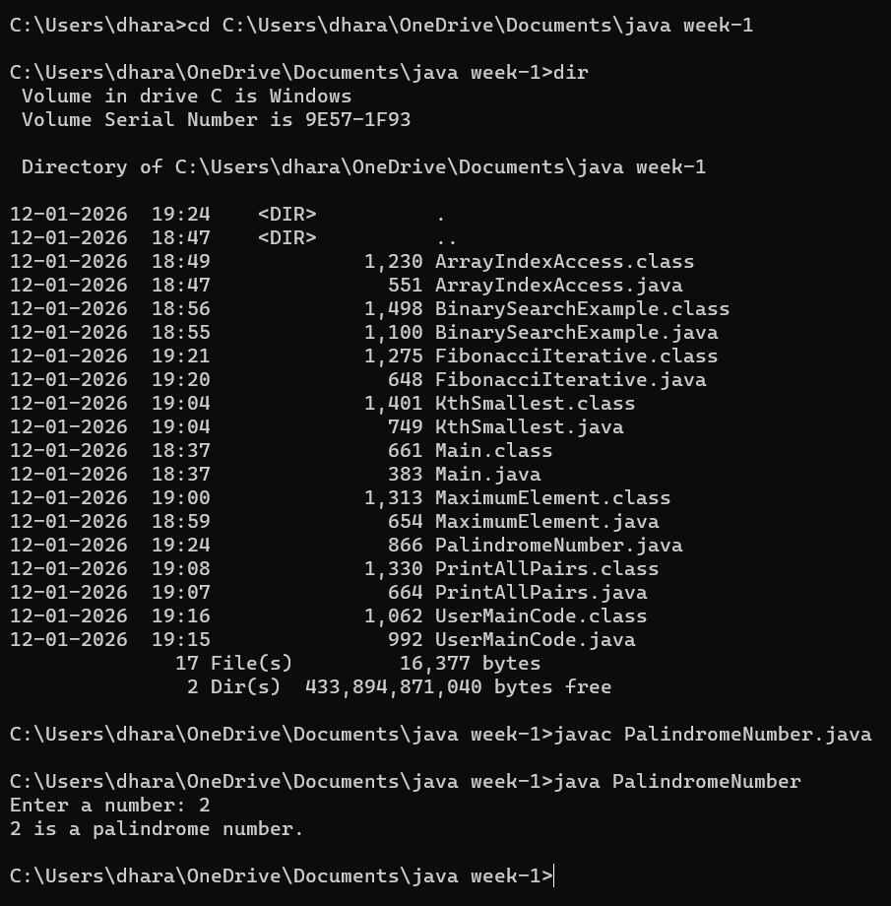

Result:Thus checking the palindrome was shown sucessfully

Task10:
AIM: To find the sum of the last digits of two given integers.
Algorithm:
- Start
- Read two integer values input1 and input2
- Convert both numbers to their absolute values to handle negative inputs
- Find the last digit of the first number using last1 = input1 % 10
- Find the last digit of the second number using last2 = input2 % 10
- Calculate the sum of the last digits o sum = last1 + last2
- Return the value of sum
- Stop Program:
class UserMainCode
{
public int addLastDigits(int input1, int input2)
{
input1 = Math.abs(input1); input2 = Math.abs(input2);

int last1 = input1 % 10; int last2 = input2 % 10;

return last1 + last2;
}
}

OUTPUT:
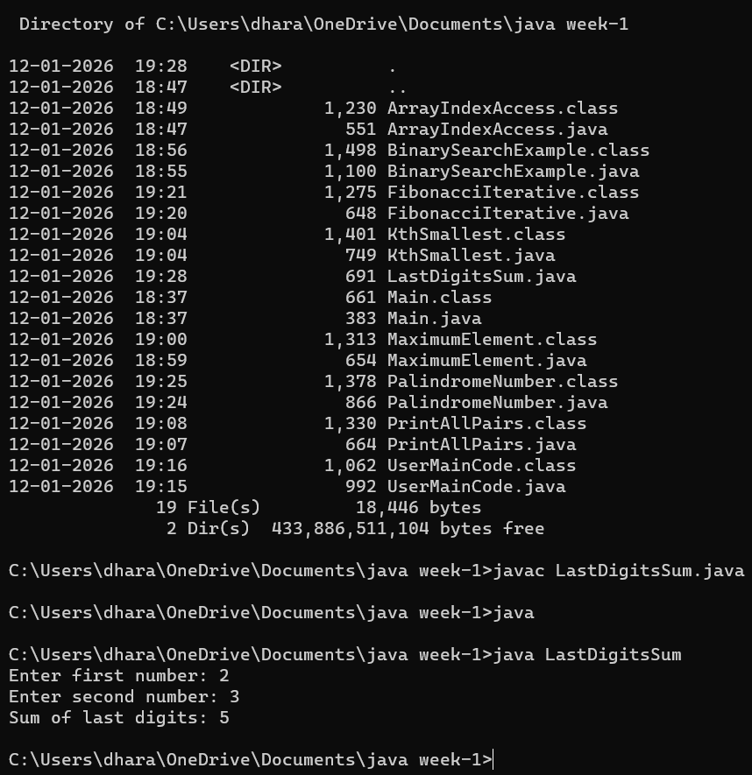

Result:Thus sum of the last two digits was shown sucessfully

